[ LOGO ]

KAOSTECH LLC

“**As Salam Anleykoum dear USERS, welcome to the first and one of a kind smart prayer rug. May Allah enlighten you and accept your prayers”**

***Kaossara OSSENI, The founder.***

**Choose your language:**

List of languages

English

Arabic

**SALAT LAYL/TAHAJJUD**

**DAILY PRAYERS**

**TRAINING**

**ZIKR**

**NAFILAH**

**JUMAH**

**TRAINING**

**ABLUTION**

**DAILY PRAYERS**

**ABLUTION / WUDU**

**ABLUTION or WUDU is a ritual purification for cleansing parts of the body before performing any formal prayers, handling and reading the QUR’AN. Some activities can invalidate your ABLUTION like urination, defecation, flatulence, deep sleep, sexual intercourses and light bleeding. Therefore it’s highly recommended to perform a fresh ABLUTION/ WUDU after eating meals.**

**NEXT >>**

**Insert ABLUTION STEP (page 65 to page 75)**

**DAILY PRAYERS / SALAT**

**A salat is a mandatory religious duty for every Muslim; it’s a physical and spiritual act of worship that should be observed 5 times a day while facing the Qiblah ( follow the compass above) in Mecca. It’s mandatory for every Muslim, except those who are menstruating, prepubescent or within the first 40 days after giving birth.**

**NEXT >>**

https://youtu.be/Kuk6HgOH9yQ

**SALAT FAJR**

**“Insert Salat FAJR Video”**

Refer to page 76 for YouTube video link

**SALAT ZUHR**

**“Insert Salat ZUHR video”**

Refer to page 76 for YouTube video link

**SALAT ASR (Afternoon)**

**“INSERT ASR VIDEO”**

Refer to page 19 for YouTube video link

**SALAT MAGHRIB (SunSet)**

**“INSERT MAGHRIB VIDEO”**

Refer to page 76 for YouTube video link

**SALAT ISHA (Night)**

**“INSERT ISHA VIDEO”**

**DAILY PRAYERS**

**FAJR**

**ZUHR**

**ISHA**

**MAGHRIB**

**ASR**

**FAJR**

**Choose the display language**

**[ENGLISH]**

**[ARABIC]**

**Choose your Surah (Chapter) for the first rakah**

**LIST OF SURAH ( CHAPTER)**

**Choose your Āyāt (Verses) for the first rakah**

**LIST OF ĀYĀT (VERSE)**

**Choose your Surah (Chapter) for the second rakah**

**LIST OF SURAH ( CHAPTER)**

**Choose your Āyāt (Verses) for the second rakah**

**LIST OF ĀYĀT (VERSE)**

**Choose your Speed**

**[SLOW]**

**[INTERMEDIATE]**

**[FAST]**

**[SUPER FAST]**

**<< DISPLAY TIMING 5 seconds for loading >>**

* **Display “ALLAH AKBAR”**
* **Display Surah 1 ( Al-Fatiha)**

**Bismillaahir Rahmaanir Raheem**

**Alhamdu lillaahi Rabbil 'aalameen**

**Ar-Rahmaanir-Raheem**

**Maaliki Yawmid-Deen**

**Iyyaaka na'budu wa lyyaaka nasta'een**

**Ihdinas-Siraatal-Mustaqeem**

**Siraatal-lazeena an'amta 'alaihim ghayril-maghdoobi 'alaihim wa lad-daaalleen**

* **Display Surah or verses choose at page 16**
* **Display “Allah Akbar again when over”**

**Display this**

**“SUBHANA RABBIYAL ADHIM”**

**Then display “ Allah Akbar ”**

**DISPLAY THIS**

**“SAMI’ ALLAHOU LIMAN HAMIDAH”**

**“RABANNA LAKAL HAMD”**

**Then display “ Allah Akbar”**

**Display this**

**“ SUBHANNA RABIYAL A’La,”**

**“Slowly whisper your wishes”**

**Then display “ALLAH AKBAR”**

**Display this**

**“ Rabbighfir li”**

**Then display “ALLAH AKBAR”**

**“Display page 20 again”**

**“DISPLAY PAGE 17 Again”**

**“DISPLAY PAGE 18 AGAIN”**

**“DISPLAY PAGE 19 AGAIN”**

**“DISPLAY PAGE 20 AGAIN”**

**Display this**

**« At-tahiyyaatu Lillaahi was-salaawaatu wat-tayyibaat. As-salaamu ‘alayka ayyuhan-Nabiyyu wa rahmatullaahi wa barakaatuhu. As-salaamu ‘alayna wa ‘ala ‘ibaad-illaah-his-saaliheen. Ash-hadu al-aa ilaaha ill-Allaah wa ash-hadu anna Muhammadan ‘abduhu wa rasooluhu**

**Allaahumma salli ‘ala Muhammad, wa ‘ala aali Muhammad, kama sallayta ‘ala Ibraaheem, wa ‘ala aali Ibraaheem, innaka hameedun majeed. Allaahumma baarik ‘ala Muhammad, wa ‘ala aali Muhammad, kama baarakta ‘ala Ibraaheem, wa ‘ala aali Ibraaheem, innak hameedun majeed »**

**Then display this « As-salamu alaykum wa Rahmatullahi wa Barakaatuhu » *2**

**ZUHR**

**Choose the display language**

**[ENGLISH]**

**[ARABIC]**

**Choose your Surah (Chapter) for the first rakah**

**LIST OF SURAH ( CHAPTER)**

**Choose your Āyāt (Verses) for the first rakah**

**LIST OF ĀYĀT (VERSE)**

**Choose your Surah (Chapter) for the second rakah**

**LIST OF SURAH ( CHAPTER)**

**Choose your Āyāt (Verses) for the second rakah**

**LIST OF ĀYĀT (VERSE)**

**Choose your Speed**

**[SLOW]**

**[INTERMEDIATE]**

**[FAST]**

**[SUPER FAST]**

**“ Display page 16”**

**«  Display Page 17 »**

**« DISPLAY PAGE 18 »**

**« DISPLAY PAGE 19 »**

**« DISPLAY PAGE 20 »**

**« DISPLAY PAGE 21 »**

**« DISPLAY PAGE 22 »**

**« DISPLAY PAGE 23 »**

**« DISPLAY PAGE 24 »**

**« DISPLAY PAGE 25 »**

**« DISPLAY PAGE 26 »**

**Display this**

**“At-tahiyyaatu Lillaahi was-salaawaatu wat-tayyibaat. As-salaamu ‘alayka ayyuhan-Nabiyyu wa rahmatullaahi wa barakaatuhu. As-salaamu ‘alayna wa ‘ala ‘ibaad-illaah-his-saaliheen. Ash-hadu al-aa ilaaha ill-Allaah wa ash-hadu anna Muhammadan ‘abduhu wa rasooluhu”**

**Then display this: “ALLAH AKBAR”**

**Display this**

**“Bismillaahir Rahmaanir Raheem**

**Alhamdu lillaahi Rabbil 'aalameen**

**Ar-Rahmaanir-Raheem**

**Maaliki Yawmid-Deen**

**Iyyaaka na'budu wa lyyaaka nasta'een**

**Ihdinas-Siraatal-Mustaqeem**

**Siraatal-lazeena an'amta 'alaihim**

**Ghayril-maghdoobi 'alaihim wa lad-daaalleen”**

**Then display “ Ameen”**

**Then display “Allah Akbar »**

**« Display page 18 »**

**« DISPLAY PAGE 19 »**

**«  DISPLAY PAGE 20 »**

**« DISPLAY PAGE 21 »**

**« DISPLAY PAGE 22 »**

**« Display page 41 »**

**« Display page 18 »**

**« DISPLAY PAGE 19 »**

**« DISPLAY PAGE 20 »**

**« DISPLAY PAGE 21 »**

**“DISPLAY PAGE 20”**

**“ DISPLAY PAGE 27”**

**ASR**

**“Display the whole ZUHR scenario from page 28 to page 53”**

**MAGHRIB**

**“Display the ZUHR scenario from page 28 to page 40”**

**“Display page 41 to page 46 then display page 53”**

**ISHAA**

**“Display the whole ZUHR scenario from page 28 to 53”**

**SALAT LAYL/ TAHAJJUD**

**Choose the number of rakah**

**[WITR]**

**[TWO]**

**[FOUR]**

**If choose [WITR] display this**

**Choose the display language**

**[ENGLISH]**

**[ARABIC]**

**Choose your Surah (Chapter) for the first rakah**

**LIST OF SURAH ( CHAPTER)**

**Choose your Āyāt (Verses) for the first rakah**

**LIST OF ĀYĀT (VERSE)**

**Choose your Speed**

**[SLOW]**

**[INTERMEDIATE]**

**[FAST]**

**[SUPER FAST]**

**If choose [Two] display page 15**

**FAJR**

**And display the whole Scenario**

**If choose [Four] display page 15**

**ZUHR**

**Then display the whole scenerio**

**JUMAH**

**FAJR**

**Display the Scenario.**

**NAFILAH**

**Choose the number of rakah:**

[**2 RAKAH]**

**[4 RAKAH]**

**FAJR**

**If user choose [2 rakah] display Scenario**

**ZUHR**

**But if user choose [4 rakah] display Scenario**

**ZIKR**

**Choose between the recommended dhikr (remembrance)**

[SUBHANALAH]

[ALHAMDULILAH]

[ALLAH AKBAR]

[LAHILA ILAH LAH]

[ASTAGFIRLAH]

**Or**

**Type your own Dhikr (remembrance)**

**[user input……]**

**Or**

**[Choose a Quranic Surat or Verse]**

**Type the number of times to display the Dhikr**

**[user numeric input ####]**

**Then display the countdown screen page 16**

**Then display the choice of the user in the electronic bead**

**Electronic BEADS**

**(The electronic beads gonna be a curved line with a couple of disc slidable from left to right and at the right hand there’s gonna be a case that’s counting the number of disc slide)**

**08**

**Step 1: Make niyyah (intention) to perform WUDU**

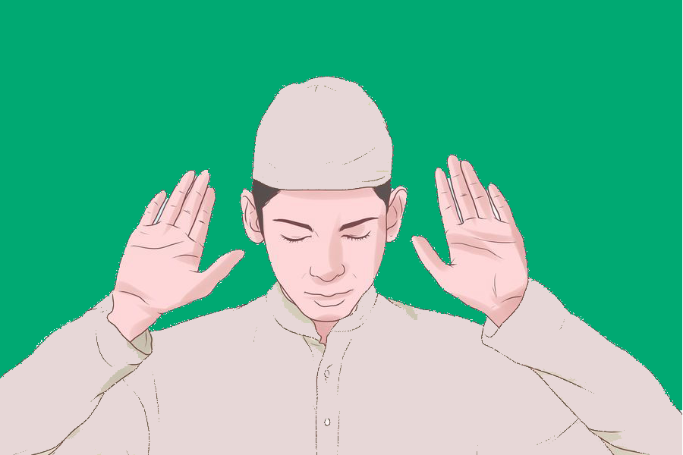

**Niyyah is the Islamic concept of performing an act for the sake of Allah. To truly perform Wudu, you should center yourself and quiet your thoughts, focusing seriously on what you are doing.**

**Niyyah doesn't necessarily involve saying anything out loud, but focusing on the phrase 'Bismillah' (In the name of Allah) is a good way to accomplish the centering necessary. Say it out loud or silently to yourself, whichever makes you comfortable.**

**Step 2: Watch your hands.**

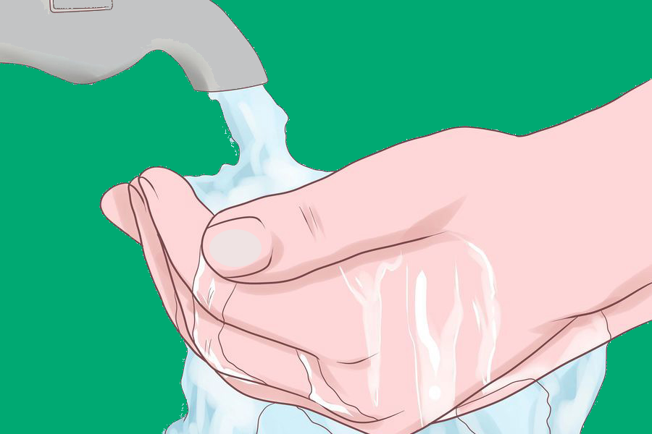

**Use your left hand to wash your right hand. Do this three times. After that, use your right hand to wash your left hand three times. Make sure to wash in between your fingers and all the way up to your wrists.**

**Step 3: Take water into your mouth.**



**Use your right hand to cup water into your mouth three times. Swish it around in your cheeks and the back of your throat. Do this thoroughly to get all the remaining food in your mouth out.**

**Step 4: Inhale water into your nose.**



**Use your right hand to cup water and inhale it into your nose three times. You can use your left hand to close one nostril and blow out if you need to. Snort sharply and abruptly without taking too much water into your nose and choking yourself. If you cannot inhale water into your nose, you can wet your fingers and put water on the lower part of your nostril.**

**Make sure to use safe water to perform this ritual; in some warmer areas of the world, water may contain naegleria fowleri, an amoeba that, if inhaled into the nostrils, can cause a rare but usually fatal type of brain infection. Even tap water may be contaminated; to avoid this illness, boil water for one minute (three minutes at higher elevations) and leave it to cool before rinsing your nose with the water.**

**Step 5: Wash your face.**



**Wash your face three times by spreading your hands from your right ear to the left, and from the edge of the hair to the chin.**

**Step 6: Wash your lower arms from wrists to elbows, leaving no part dry.**



**From your wrist to your elbow, wash your right arm with your left hand three times and then wash your left arm with your right hand three times.**

**Step 7: Clean your head.**

**Using your wet hands, gently wipe your forehead from the eyebrow to the hairline. Also wipe down your hair, the back of your neck, and your temples. Do this one time.**

**Step 8: Wipe your ears inside and out.**



**With the same water, use your finger to clean all the crevices of your ear. Use your thumb to clean behind your ears from the bottom upward. This is also done one time.**

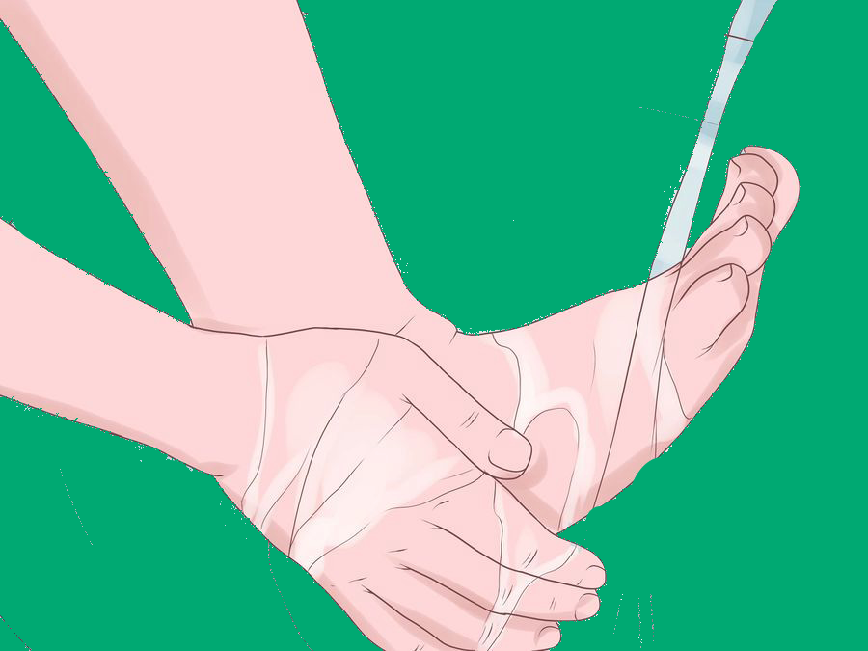**Step 9: Wash each of your feet.**

**Clean up to the the ankles and be sure water goes between the toes. Use your pinky finger and go through each toe to eliminate anything between. Start with your right foot and scrub each foot three times.**

**Step 10: While pointing the right index finger to the sky**



**Generally, the prayer is as follows: 'Ash-hadu anlaa ilaaha illALLAHu wahdahuu laa shariikalahu, wa ash-hadu anna Muhammadan 'abduhuu wa rasuuluhu.'**

**In English, this is translated as 'I bear witness that there is no deity other than Allah alone; He is One; He has no partner and I bear witness that (Hadrat) Muhammad (sallallahu ala Muhammadu sallallahu alaihu Wasallam) is His (chosen) servant and (true) Messenger.'**

**Step 11: Repeat WUDU after it has been nullified.**



**Actions that nullify Wudu include natural discharges, including urination, defecation, excessive bleeding, and gas. Deep sleep also nullifies WUDU.**

**YouTube links:**

**Fajr:** [**https://youtu.be/Kuk6HgOH9yQ**](https://youtu.be/Kuk6HgOH9yQ)

**ZUHR:** [**https://youtu.be/Nq3Fa-mwNeE**](https://youtu.be/Nq3Fa-mwNeE)

**ASR:** [**https://youtu.be/IoOSSoL-U7E**](https://youtu.be/IoOSSoL-U7E)

**MAGHRIB:** [**https://youtu.be/MXl0pvdi8fw**](https://youtu.be/MXl0pvdi8fw)

**ISHA:** [**https://youtu.be/g9l4u_EIqOI**](https://youtu.be/g9l4u_EIqOI)

**Logo**

